JavaQueueCircularArray output images

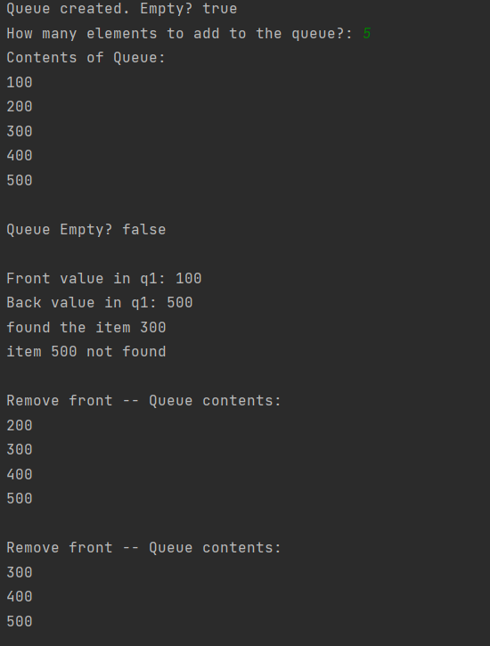

Palindrome Output file Screenshot:

